Extract data from a uri with request and beatufullsoup

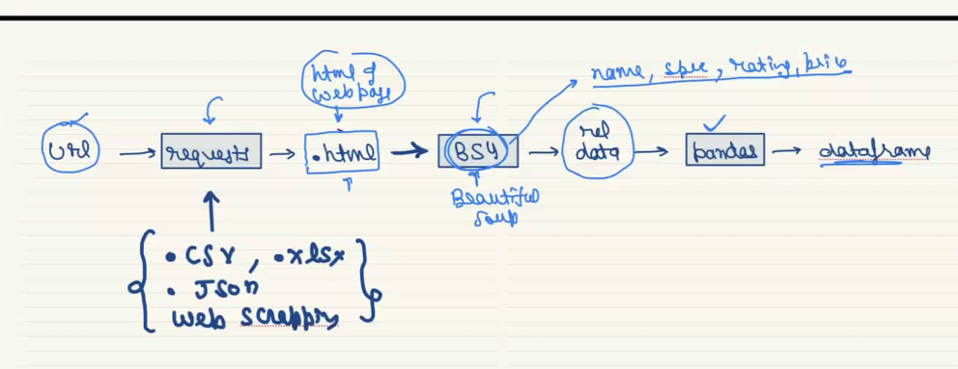

Take contact details from resume text email, phone no

And add it to the exsisting DF we have yesterday

EX output:

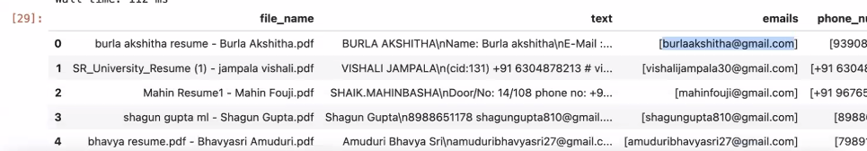

Py -2 ml-3 pt-2 rcs-3

